**Black Scholes Option Pricing Model**

## Algebraic Manipulation

* 
* 
* 
* 

# Normally Distributed Returns

Skipping the formal proof, we can also obtain the **Conditional Expectation**:



* 
* The logic can be understood as follows:
  + 
  + 
  + 

## Using Historical Data

* 
* We can follow the three step process to determine the parameters from historical data:

Most likely, the data will be given in **monthly format**. We will first need to convert the data into a **continuously compounded format**,



Next, we can calculate the Sample Mean and Sample Standard Deviation using the **Calculator Function**,



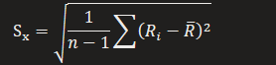

Lastly, we convert them to **ANNUAL format**,





## Relation to Forward Prices

* Logically speaking, we would only enter a forward contract if we **expect** a positive payoff from it
* Thus, Expected Stock Price should always be **larger than the Expected Stock Price**









More generally, we can express it in the form of **Prepaid Forward Prices:**

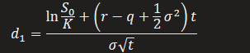

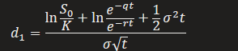

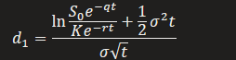

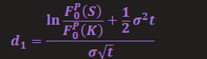

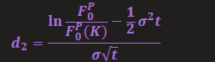

|  |  |
| --- | --- |
| **Call Option** | **Put Option** |
|  |  |









